Parish Income and Expenditure Account  2022 2021  Income € €  Donations 18,509 7,500  Family Offering (envelopes and standing orders) 87,122 90,110  Tax refund 22,047 3,417  Fundraising (excl. church renovation) 762 27,072  Rent 34,858 21,444  Shrine 5,305 5,525  Other Income 6,686 16,357  Total Income 175,289 171,425  Expenses  Staff costs 100,021 100,956  Office Expenses/Administration 15,211 14,246  Pastoral Expenses 18,839 8,409  Utilities 41,262 30,069  Rent rates 3,234 3,435  Professional fees 29,489 4,021  Other expenses 2,922 6,580  Total Expenses (excl. depreciation) 210,978 167,716  Profit -35,689 3,709 |  | 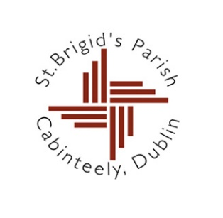 | St Brigid’s Parish Church  Cabinteely  Dublin 18
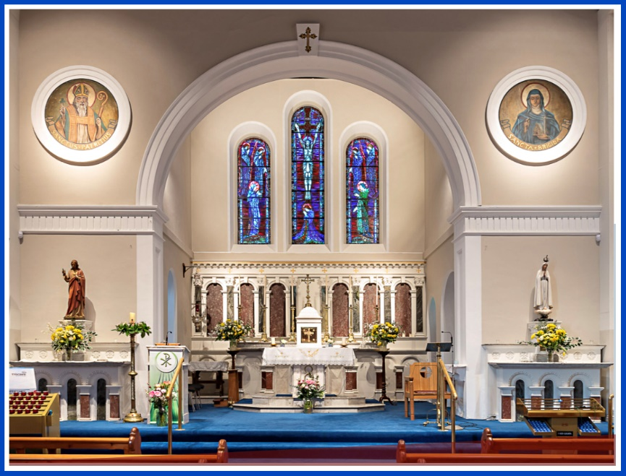
Photo: John Hickey

Message to Parishioners

From

Parish Finance Committee

November, 2023

Message from the Parish Finance Committee to Parishioners  Dear Fellow Parishioners,  Much has happened since we last communicated with you in respect of the Parish’s finances. It is therefore timely, and proper, that we should now bring you up to date, specifically on two areas - the refurbishment work in the church, and the ongoing state of the Parish finances generally.  Church Refurbishment  During 2019 we approached you to seek your support to renovate the Church building. A major refurbishment job was required to bring the church in line with health and safety legislation with a likely cost in the region of €500,000.  The response of parishioners was very supportive, to the extent that by early 2020 the level of funding contributed, while not yet at that time at a level to cover the entire cost of the project, was nonetheless sufficiently encouraging to allow a decision to be made to proceed with the planned work.  However, the advent of the Coronavirus impacted the refurbishment, leading to huge delays beyond the planned timescale for the work. But, in a perverse way, the delays facilitated the completion of the project. While it had initially been planned to carry out the work on a phased basis as funding allowed, by the time the work did get under way the level of contributions was sufficient to finance the entire project.  The renovation has received widespread approval and has been completed without incurring any debt. We now have a Church which we all can be proud of, and which will serve future generations of parishioners. This would not have been possible without the extraordinary generosity of our parishioners. For this we are truly grateful. A special thanks is due to Fr. Aquinas, who has now moved to his new parish in Wicklow, but who devoted huge energy to the project whilst here in Cabinteely.  The table below outlines the financing of the project:  Church Renovation Fund  €  Fundraising Income 468,446  Renovation Costs to Date 420,649  Balance Still Owing 23,426  Surplus on Account – Transferred to Parish 24,371 |  | Parish Income and Expenditure  The day-to-day running of our Parish requires a not insignificant level of funding and cannot happen without the support of its parishioners. As with the refurbishment work, the support of our parishioners has always been most generous and has allowed the parish to deliver a wide range of pastoral and community services.  By way of explanation, parishioners contribute financially on an ongoing basis in various ways:  - Collections at Mass  - Christmas, Easter and Summer Dues  - The Planned Giving Programme (Family Offering).  Contributions received by way of the first two of these methods (Mass Collections and Dues) are not available to the Parish - they are used by Archbishop’s House for various Diocesan needs, such as supporting priests of the Archdiocese, including those who are retired or sick. They also fund Diocesan administration, pastoral workers and the upkeep of church property.  The Planned Giving Programme (Family Offering) is, therefore, the most important source of income to cover day-to-day Parish running costs. Figures for income and expenditure for 2021 and 2022 are presented overleaf.  As you can see, parishioners have continued to contribute generously, despite the challenges of the pandemic and escalating costs of living. However, running costs are increasing in line with developments in the wider economy. We had a small surplus in 2021, but incurred a deficit of €36K in 2022. This reflects not only increasing costs, but falling incomes from dwindling mass attendance. This deficit is not sustainable in the longer-term, so we need to take steps to address the short-fall. As we operate on a very tight budget, it is difficult to reduce costs without negatively impacting the range of services provided by our Parish. We are, therefore, reluctantly calling once again, on the generosity of our parishioners. If you are in a position to help, we would ask you to do so. This can be organised online via the Parish website, or directly with the Parish Office.  Many among you continue to make a contribution by way of a standing order through your bank or other financial institution. If you are not already contributing in this way, we would ask you to give some consideration to whether you are in a position to do so. A form to facilitate this is attached. Please note that the Parish can claim a tax refund from Revenue for all donations in excess of €250 in a given year.  Again, we thank you for your support, and wish you every blessing in your personal and family lives

