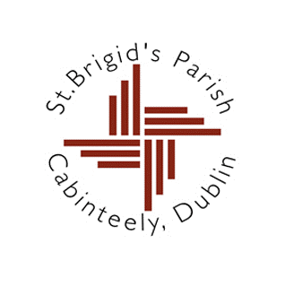

13th September 2023

Dear parents,

My name is Fr Donal Roche. I am the new Parish Priest of Cabinteely, replacing Fr Aquinas who has just moved to Wicklow. I am looking forward to meeting you over the coming weeks as we begin the process of preparation for the Sacraments of First Reconciliation (Confession) and First Holy Communion in 2024.

Although these sacraments are often seen as school events, it is important to emphasise that they are a very important part of a child’s growth in faith and a means for parents to pass on their own Christian faith to their children. In recent years moves have been made to make the sacraments more parish rather than school-based, emphasising the commitment made by the parents at baptism to bring their child up in the Catholic faith.

If you would like to enrol your child for the sacraments, I am writing to invite you to an information meeting in St Brigid’s Church on **Wednesday 27th September at 7.30 pm** to outline what is involved in the parish preparation programme.

Please note that the meeting is in the Church, not the school. Parking in the Church grounds is very limited so please be prepared to park and walk to get to the Church.

If neither parent is free to attend the meeting but you still wish to enrol your child please let me know so that we can arrange to meet at an alternative time. You can contact the parish office at (01) 2858835 during office hours.

It is my hope that together with the teachers we can work to make sure that the celebration of these sacraments is a meaningful and memorable event in the life of your child.

With kind regards,

Yours sincerely,

Fr. Donal Roche