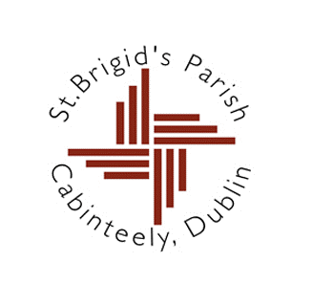

13th September 2023

Dear parents,

My name is Fr Donal Roche. I am the new Parish Priest of Cabinteely, replacing Fr Aquinas who has just moved to Wicklow. I look forward to meeting you over the coming weeks as we begin the process of preparation for the Sacrament of Confirmation, which will take place in St. Brigid’s Church in 2024.

If you would like your child to apply to receive the sacrament, I am inviting you to a meeting in St Brigid’s Church on **Wednesday 20th September at 7.30 pm**. At this meeting, I will outline what is involved in the programme of preparation for Confirmation, which will take place both in the school and in the parish.

Please note that the meeting is in the Church, not the school. Parking in the Church grounds is very limited so please be prepared to park and walk to get to the Church.

If neither parent is free to attend the meeting but you still wish to enrol your child please let me know so that we can arrange to meet at an alternative time. You can contact the parish office at (01) 2858835 during office hours.

It is my hope that together with the teachers we can work to make sure that the celebration of this sacrament is a meaningful and memorable event in the life of your child.

Kind regards,

Yours sincerely,

Fr. Donal Roche