GROW & DLR Social Prescribing Programme for Health & Wellbeing

Community Mental Health Movement in Ireland

COMMUNITY EDUCATION PROGRAMME

Understanding and Minding your Mental Health

Rebuilding our mental Resilience

COMMENCES: Thursday 15th July 2021 (for 5 weeks)

Time: 19.00 – 20.00
Venue: zoom
These events are FREE to attend.

- Week1:Thursday 15th July: Understanding & Promoting Positive Mental Health
- Week 2: Thursday 22nd July: Dealing with Change
- Week 3: Thursday 29th July: Dealing with Anxiety
- Week 4:Thursday 05th August: Healthy Mindset
- Week 5:Thursday 12th August: Procrastination & moving forward
- See below information on each presenter
To REGISTER please email: niamhgilmore@grow.ie
The Healthy Ireland Fund supported by the Department of Health and the Department of Children, Equality, Disability, Integration and Youth
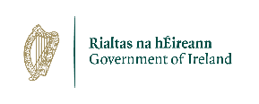
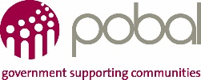
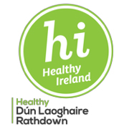

GROW & DLR Social Prescribing Programme for Health & Wellbeing

Community Mental Health Movement in Ireland

- Week1:Thursday 15th July: Understanding & Promoting Positive Mental Health
Niamh Gilmore (GROW), John Farren (GROW) and Lisa (DLR Social Prescribing)

- Week 2: Thursday 22nd July: Dealing with Change
Jean McElvaney

- Week 3: Thursday 29th July: Dealing with Anxiety
Avril Bailey

- Week 4:Thursday 05th August: Healthy Mindset
Danielle Serpico

- Week 5:Thursday 12th August: Procrastination & moving forward
Jean McElvaney

